 | MAYURBHANJ MEDICAL ACADEMY  AT-INDAPAHI, PO-LAXMIPOSI, DIST-MAYURBHANJ, ODISHA, PIN-757107  (RECOGNIZED BY GOVT. OF ODISHA & APPROVED BY PCI, NEW DELHI & AFFILIATED TO BPUT Rourkela & OUHS Bhubaneswar, OSBP Bhubaneswar, ODISHA)  Website- www.mmabpd.ac.in,  Email ID-mmabpd@rediffmail.com

Submitted in partial fulfillment of the
requirements of
Project work
(BP812PW)
of Final Year B. Pharm (SEMVIII)
Academic Year 2025 - 2026
Executed in
(Department of Pharmacology)
By
Mr. Bikash Kumar Mahakud

( Regd. No. 2203409011)

Supervisor: Dr. Susanta Kumar Rout

MAYURBHANJ MEDICAL ACADEMY, BARIPADA
AT- INDAPAHI, P.O- LAXMIPOSI, BARIPADA
DIST-MAYURBHANJ, ORISSA, INDIA, PIN - 757107

CERTIFICATE
This is to certify that the project entitled “phytochemical screening and nutritional assessment of Zingiber officinale.”is a Bonafide work of Mr. Bikash Kumar Mahakud ( Regd. No. 2203409011) executed in the Department “Pharmacology” and submitted to the MAYURBHANJ MEDICAL ACADEMY Affiliated to Biju Patnaik University of Technology, Rourkela, Odisha in partial fulfilment of the requirement for the completion of Practice School (BP812PW) of Final Year B. Pharm (SEM VIII) Academic Year 2025 – 2026

(Dr. Susanta Kumar Rout) College seal
Supervisor

(Dr. Susanta Kumar Rout) (Dr. Susanta Kumar Rout )
Head of Department Principal

APPROVAL SHEET

Project work Report Approval for B. Pharm

This Project work report entitled “phytochemical screening and nutritional assessment of Zingiber officinale.” by Mr. Bikash Kumar Mahakud (Regd. No.2203409011) is approved for consideration towards the completion of Project work (BP812PW) of Final Year B. Pharm (SEM VIII) Academic Year 2025 - 2026.
.
Examiners

1.

2.

Date:
Place:

DECLARATION
I hereby declare that the work published in this project work report entitled, “Topic - phytochemical screening and nutritional assessment of Zingiber officinale.” which is being submitted by me in partial fulfilment for of the requirements of Project work Report (BP812PW) to the MAYURBHANJ MEDICAL ACADEMY Affiliated to Biju Patnaik University of Technology, Rourkela, Odisha, is the result of investigations carried out by me under the Guidance of Dr. Susanta Kumar Rout. I also declare that I have adhered to all principles of academic honesty and integrity and have not misrepresented or fabricated or falsified any idea/ data/ fact/ source in my submission. I further declare that to the best of my knowledge the report does not contain any part of any work, which has been submitted for the award of any degree either any university /deemed university without proper citation.

Place: Mr. Bikash Kumar Mahakud
Date: (Regd. No. 2203409011)

ACKNOWLEDGEMENTS
I would like to take this opportunity to thank my supervisor and mentor,
Dr. Susanta Kumar Rout, Professor and Head, Department of Pharmacology, MAYURBHANJ MEDICAL ACADEMY, for his encouragement, inspiration and guidance throughout the tenure of my research. He always provided inspiration, priceless and prudent guidance, much needed constructive criticism, encouragement, persistent help and above all her upbeat approach towards my abilities made the achievement of this goal, a learning, rewarding and enlivening experience. I am deeply indebted and express deep sense of gratitude to Mr. Ashok Kumar Dwari, Chairman cum Director, MAYURBHANJ MEDICAL ACADEMY, BARIPADA who gave me the opportunity to work and providing excellent facilities for work. I warmly thank to Dr. Susanta Kumar Rout, Principal, for their valuable advice. I express my special thanks to Dr. Susanta Kumar Rout for his continuous support, untired efforts, valuable suggestions, constructive criticisms and continuous discussions throughout my research work.
My sincere thanks are due to MR. ANANTA PATRA and MR. AKASH KAR , MMA, Baripada for helping me in doing my study. I also appreciate insightful discussions with all teaching and non-teaching staffs for whom I have great regard, and I wish to extend my warmest thanks to all those who have helped me with my work at the MAYURBHANJ MEDICAL ACADEMY, BARIPADA.I am deeply grateful to my father and mother for their incredible support. I also would like to acknowledge my sincere thanks to all my friends. I would like to thank God Almighty for giving me the opportunity and guidance to achieving my goal and to be successful in this part.

Place: Mr. Bikash Kumar Mahakud
Date: (Regd. No. 2203409011)

ABSTRACT
Metformin hydrochloride is a drug of choice in the treatment of diabetes mellitus type-2 especially in obese patients. It is normally given orally as tablets in doses of 500 mg two or three times daily or 850 mg once or twice daily during or after meals. The aim of the present study was the comparative study and evaluation between five different Metformin hydrochloride brands which are commercially available in the Libyan drug market to assess quality, all products were examined visually for their organoleptic properties. The physicochemical equivalence of five brands of Metformin hydrochloride tablets were determined through the evaluation of official standards according to the USP pharmacopoeia including uniformity of weight, friability, hardness, disintegration, dissolution rate and drug content. A variation of the
concept of dissolution efficiency (DE), known as predicted availability equivalent (PAE), was used to predict the likely in vivo bioavailability. All the tested five brands were equivalent and complying with the official tests for weight variation, friability, hardness, disintegration and dissolution tests. The friability test was within the specified limit. All formulations were disintegrated within 15 -30 min. The tested brands were identical according to their dissolution evaluation. The percentage content of active ingredient of five brands of Metformin tablets showed values within the monograph specifications (95-105%). All the brands are within their expiry dates but there is major difference in price. The basic function groups of five metformin brands and metformin standard was identified by Infra-Red (IR) spectrophotometer. The spectroscopic investigations were revealed no any difference between Metformin five brands and showed identical peaks compared to the All the available brands in local market of Libya are having, with in the specified quality range and can be interchange of found any non-compliance due to cost issue. The results have shown that all the tested brands satisfied the USP requirements.

CONTENT

Certificate i
Approval sheet ii
Declaration iii
Acknowledgment iv
Abstract v

1.INTRODUCTION
2.LITERATUREREVIEW -
3.AIMSANDOBJECTIVES
4.METHODOLOGY
5.RESULT AND DISCUSSION
6.SUMMERY AND DISCUSSION
7.CONCLUSION
8.REFERENCES

CHAPTER 1

INTRODUCTION

INTRODUCTION
According to a WHO 2016 report, diabetes mellitus is commonly classified \as Type 1 or Type 2 diabetes. Type 2 diabetes was the major cause of total diabetes prevalence and affects every population. The number of patients with diabetes mellitus is increasing.
Accordingly the number of adult patients was 422 million in 2014 worldwide. The prevalence was 4.7% in adults in 1980 which becomes 8.5% in the year 2014, and the rise was high in low- and middle-income countries. Besides, according to an International Diabetes Federation projection there will be 552 million diabetic patients by 2030 and most of them will be living in low- and middle-income countries. Each year four million deaths in the world are attributed to diabetes mellitus, and in 2017 the annual expenditure was 850 billion US dollars. Unless otherwise halted the socioeconomic consequences will be huge.– However, the World Health Organization reported that 30% of drugs sold in Africa were poor quality. This fact might be attributed to weak regulatory systems and/or limited resources. Chemically, metformin HCL was N, N-dimethyl-imido-dicarbonimidic diamide hydrochloride (Figure 1). The molecular weight of metformin is 129 Da and it has low solubility in lipid media. Due to this, the ability of the drug to pass the cell membrane is low As per the Biopharmaceutics Classification System (BCS), it is class III drug. Therefore, permeability is the rate-limiting step in drug absorption.
Dissolution is the critical quality control parameter for drugs as it has direct impact on absorption. Fast dissolution is required to enhance contact time of the dissolved drug with absorption mucosa. So, the duration of dissolution should be hardline for such drugs. In vitro in vivo correlation (IVIVC) serves as a surrogate for in vivo bioavailability and to support bio-waivers. IVIVCs could also be employed to establish dissolution specifications and to support and/or validate the use of dissolution methods Dissolution as a quality control tool for forecasting in vivo performance of a drug product is significantly enhanced if an in vitro-in vivo relationship is established. The in vitro test serves as a tool to differentiate passable and impassable drug products. Passable products are bioequivalent in terms of in vivo performance and vice versa The absorption of drugs after oral administration depends on various factors from which the release of the drug substance from the dosage form, its dissolution in physiological conditions, and its permeability through the gastrointestinal tract, and the tests are mainly used to assure the quality of the pharmaceutical product. Different methods for comparisons of dissolution profiles of different tablets are suggested by SUPAC-IR from those statistical analyses by one-way analysis of variance, model-dependent and model-independent parameters are common.
Even though there are different brands of drugs introduced into the world pharmaceutical market to improve public health outcome, the proportion of poor quality drugs are increasing proportionally worldwide. The study done in Albania to check the interchangeability of three brands of metformin HCL indicated that two of the brands could be used interchangeably Another study done in Asia (Qatar) to assess bioequivalence and interchangeability of 10 different brands of metformin hydrochloride revealed that only six of the brands could be used interchangeably with the comparator.
Similar to other parts of the world, the African continent as a whole is also facing a great challenge in the quality of medicines. The study done in Nigeria for comparative evaluation of the physicochemical properties of some commercially available brands of metformin HCL tablets on eight different brands showed that only four of the brands are bioequivalent and can be used interchangeably. Therefore, the aim of the study was to evaluate and compare dissolution profile of different brands of metformin hydrochloride tablets available in Metformin HCl is an oral anti-diabetic drug from the biguanide class used mainly to treat type 2 diabetes mellitus. Metformin hydrochloride works by improving the body’s sensitivity to insulin, allowing it to use glucose in the normal way.
It is the first-line drug of choice for the treatment of type 2 diabetes, particularly in overweight and obese people and those with normal kidney function. Metformin hydrochloride is also being used increasingly in polycystic ovary syndrome (PCOS) which is a syndrome of ovarian dysfunction and hyperandrogenism. Evidences suggest that insulin resistance and resulting hyper insulinaemia play a central role in the pathogenesis of the syndrome.
Metformin, an insulin sensitizer, not only improves hyperandrogenism but also improves ovulation as well as pregnancy rates in patients with PCOS, nonalcoholic fatty liver disease (NAFLD) and premature puberty. Metformin was first described in the scientific literature in 1922, by Emil Werner and James Bell, as a product in the synthesis of N, Ndimethyl- guanidine free user. French physician Jean Sterne published the first clinical trial of Metformin as a treatment for diabetes. It was introduced to the United.
Kingdom in 1958, Canada in 1972, and the United States in 1995 Drug products that are biopharmaceutically and chemically equivalent must be identical in their quality, strength, purity and active ingredient release profile. They must to be in the same dosage form and intended for the same route of administration. Dissolution testing of drug product is an important criterion in assessing the quality control to monitor batch to batch consistency of drug release. The variations in the drug release among some generics indicate deficiency in the entire drug formulation and the delivery system. Dissolution rate determination used also for prediction of in-vivo bioavailability in most oral preparations. Manufacturing methods and the excipients used in the production processes could contribute to the quality and release skillfulness of medicament. Therefore, to ensure the requisite quality, drug manufacturers are required to examine their products during and after manufacturing and at various intervals during the shelf life of the product. Accordingly, to ensure that the generic and branded drugs products are pharmaceutically equivalent cannot be overemphasized. So, the selection of one product from several generic drug products of the Life Science Journal 2012 same active ingredients is concerned important for healthcare workers. Metformin hydrochloride is the most popular anti-diabetic drug in the Saudi kingdom as well as all over the world. As reported by the annual statistical studies (MOH annual statistical book 2010) more than 25%

CHAPTER 2
LITERATUREREVIEW

LITERATUREREVIEW
Presen study was the evaluation of different & comparison between six different Metformin hydrochloride. The physicochemical equivalence of six brands of Metformin hydrochloride tablets Thus, the aim of this work to develop & conduct a comparative study utilizing three novel methods. In the present study the effect of metformin & metformin conjugated. A comparative study on effect of metformin & metformin conjugated nanotubes on blood glucose homeostasis in diabetic rats. Pure metformin hydrochloride was gifted as a free sample, various brands of metformin comparative study.
2. HM Lofty, D Mohamed, S MOWAKA
DESCRIPTION: Present study was the evaluation of different & comparison between six different Metformin hydrochloride. The physicochemical equivalence of six brands of Metformin hydrochloride tablets Thus, the aim of this work to develop & conduct a comparative study utilizing three novel methods. In the present study the effect of metformin & metformin conjugated. A comparative study on effect of metformin & metformin conjugated nanotubes on blood glucose homeostasis in diabetic rats. Pure metformin hydrochloride was gifted as a free sample, various brands of metformin comparative study.
3. N Mirazi, J Shoaei, A Khazaei, A Hosseini
DESCRIPTION: Presen study was the evaluation of different & comparison between six different Metformin hydrochloride. The physicochemical equivalence of six brands of Metformin hydrochloride tablets Thus, the aim of this work to develop & conduct a comparative study utilizing three novel methods. In the present study the effect of metformin & metformin conjugated. A comparative study on effect of metformin & metformin conjugated nanotubes on blood glucose homeostasis in diabetic rats. Pure metformin hydrochloride was gifted as a free sample, various brands of metformin comparative study. 4. E M Rodrigues Neto, LARV Marques, G H Cunha DESCRIPTION: Present study was the evaluation of different & comparison between six different Metformin hydrochloride. The physicochemical equivalence of six brands of Metformin hydrochloride tablets Thus, the aim of this work to develop & conduct a comparative study utilizing three novel methods. In the present study the effect of metformin & metformin conjugated. A comparative study on effect of metformin & metformin conjugated nanotubes on blood glucose homeostasis in diabetic rats. Pure metformin hydrochloride was gifted as a free sample, various brands of metformin comparative study.
5. A Jain, J Chaudary, A Saini
DESCRIPTION: Presen study was the evaluation of different & comparison between six different Metformin hydrochloride. The physicochemical equivalence of six brands of Metformin hydrochloride tablets Thus, the aim of this work to develop & conduct a comparative study utilizing three novel methods. In the present study the effect of metformin & metformin conjugated. A comparative study on effect of metformin & metformin conjugated nanotubes on blood glucose homeostasis in diabetic rats. Pure metformin hydrochloride was gifted as a free sample, various brands of metformin comparative study.

CHAPTER 3
AIMS AND OBJECTIVES

AIMS AND OBJECTIVES

Aim:

A Comparative study for evaluation of different brands of metformin hydrochloride 500 mg tablets marketed in india.

Objectives:
The objective of the present study was the evaluation and comparison between four different Metformin hydrochloride brands which are commercially available in the India market. ii. The physicochemical equivalence of six brands of Metformin hydrochloride tablets were determined through the evaluation of both official and non-official standards according to the USP pharmacopoeia including uniformity of weight, friability, hardness, disintegration, dissolution rate and drug content. iii. To evaluate the pharmaceutical quality of different brands of metformin hydrochloride tablets available in Indian market

DRUG PROFILE
Structure
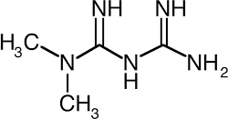HCL

synonyms
- metformin
- 657-24-9
- 1,1-Dimethylbiguanide
- N,N-dimethylimidodicarbonimidic diamide
- Fluamine

Molecular Weight
129.16 g/mol

DESCRIPTION Metformin is a member of the class of guanidines that is the carrying two methyl substituents at position 1. It has a role as a hypoglycemic agent, a xenobiotic, an environmental contaminant and a geroprotector. It is functionally related to a . It is a conjugate base of a metformin (1+). Metformin is a antihyperglycemic agent and first-line pharmacotherapy used in the management of type II diabetes. Metformin is considered an antihyperglycemic drug because it lowers blood concentrations in type II diabetes without causing hypoglycemia. It is commonly described as an "insulin sensitizer", leading to a decrease in insulin resistance and a clinically significant reduction of plasma fasting insulin levels. Another well-known benefit of this drug is modest weight loss, making it an effective choice for obese patients type II diabetes. Metformin was first approved in Canada in 1972, and received subsequent FDA approval in the US in 1995.

CHAPTER 4
METHODOLOGY

METHODOLOGY
Friabilator, Hardness tester, Analytical balance, Dissolution apparatus & UV spectrophotometer.
Table No 1: Instruments used for Project.

Sr.no | Name of instruments | Model no.
1 | Hardness Tester | Pfizer
2 | Friability Apparatus | LABINDIA
3 | Dissolution apparatus | LABINDIA DS 8000
4 | Digital weighing balance | CONTECH INDIAS LARGEST MFGR OF BALANCES SINCE 1992
5 | Double beam UV spectrophotometer | Model no. AU-2702

- Visual inspection shape, size and color of tablets was inspected. Table No 2: Visual Inspections.
Walaphage | - Chemical name: Metformin HCL 500  - 1 strip contains 20 uncoated tablets  - Rectangular in shape  - White in colour
Okamet | - name: Metformin HCL 500  - 1 strip contains 20 uncoated tablets  - Caplet in shape  - Chemical White in colour
Glyciphage | - Chemical name: Metformin HCL 500  - 1 strip contains 20 uncoated tablets  - Ovale in shape  - White in colour
Glycomet | - Chemical name: Metformin HCL 500  - 1 strip contains 10 uncoated tablets
- Round in shape
- White in colour

- Uniformity of weight
To ensure the consistency of dosage units, each unit in a given batch should contain the active drug within a narrow range around the label claim. The uniformity of dosage units can be evaluated either by measuring the content uniformity or the weight of the tested units
- The test for weight variation is applicable for hard capsules, uncoated tablets and film- coated tablets containing 25 mg or more of a drug substance comprising 25% or more, by weight, of the dosage unit or, in the case of hard capsules, the capsule contents, except that uniformity of other drug substances present in lesser proportions is demonstrated by meeting the requirements for content uniformity.
- Unless the 25 mg/25% threshold limit is met, the use of the mass/weight variation test as an alternative test for content uniformity is not considered interchangeable in all International Conference on Harmonization (ICH) regions.
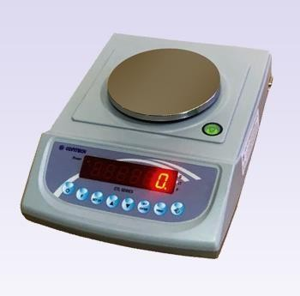
- Fig No 1 – Weighing Balance.

- Friability test
  - Ensure that the instrument is clean & dust free.
  - Weigh accurately the number of tablets & carry out the procedure as described in the monograph.
  - Open the apparatus from the removable side of the drum.
  - Transfer the tablets in it & close the drum.
  - 20 tablets of each brand weigh the initial weight then add into friabilator for 100

revolution for 4min then tablets were dedusted & weighed again. The percentage weight loss was calculated.
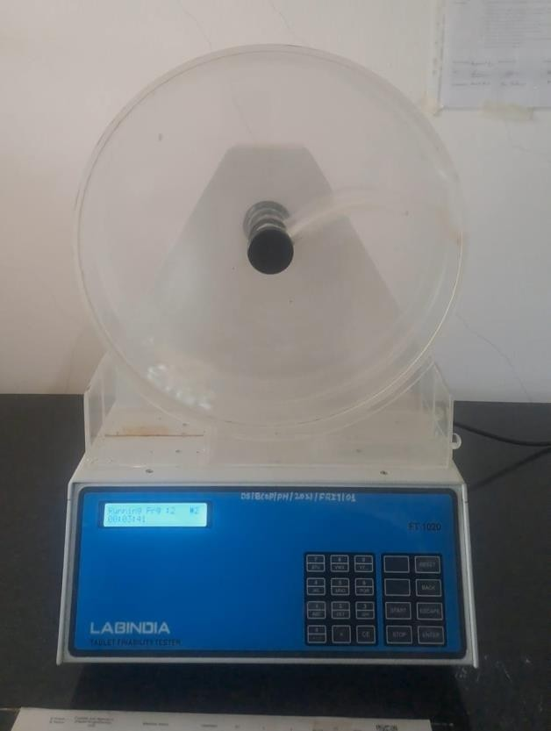
Percentage friability=(initial wt - final wt/initial wt)100

Fig No 2 – Friability Apparatus.

  - The unit is equipped with two transparent acrylic drums which rotate at a speed of 25rpm. Each of the two acrylic drums are provided with an arm which carries the tablets along with it up to a predetermined height and allows them to fall from that specified height.

- Hardness test
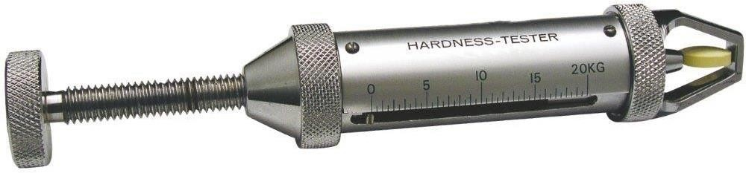
Fig No 3 – Hardness tester.

- 10 tablets from each brands were diametrically compressed until fracture
- Tablet hardness" is a measure of the force required to break a tablet in a test apparatus that places the tablet under a tension or bending load. The hardness of a tablet plays a

crucial role in its efficacy and overall performance, especially during packaging, shipping, and patient use.

Impact of formulation on hardness
- Tablet formulation, including the choice and proportion of ingredients, can significantly impact tablet hardness. An optimal balance between the quantity of API, binder, and lubricants is essential to achieve the desired hardness.

Role of excipients in hardness
- Excipients, like binders and granulating agents, are pivotal to enhancing tablet hardness. They bind the tablet particles together, thereby increasing the mechanical strength of the tablet.

Effect of active pharmaceutical ingredients (API) on hardness
- The nature and amount of API can affect tablet hardness. For instance, some APIs may influence the tablet compression operation, leading to hardness variation.

- The influence of manufacturing processes on hardness
Various manufacturing processes, including milling, blending, granulation, and potentially affect.

- Disintegration Time detection
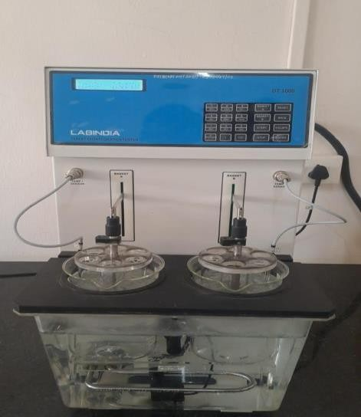
Fig No 4: Disintegration Apparatus.

- One tablet or capsule is placed in each of the six tubes of the basket.
- If specified, a disc is added to each tube.

- The basket-rack assembly is suspended in the beaker and the apparatus is operated for a predetermined time.
- The time limit for disintegration varies depending on the dosage form (e.g., 15 minutes for uncoated tablets, 3 minutes for soluble tablets).

- Assay on UV spectrophotometer
Procedure.

Preparation of stock solution
- Weight accurately 100mg pure drug & mix with 50 ml of distilled water
- Transfer 10ml again make up of volume income to be a working solution (100μg/ml)

Preparation of sample solution
- Weigh & powdered the 20 tablets
- Weigh accurately the powder equivalent to 0.15gm of metformin hydrochloride then add 50ml of distilled water & dilute up to 100ml
- Shake for 15 min & add sufficient quantity of distilled water
- Dilute 10ml of filterate with 100ml distilled water
- Measure the absorbance of sample solution &plot the calibration curve between to get the content
- Consider the A1%cm of metformin hydrochloride at 233nm & calculate the test sample
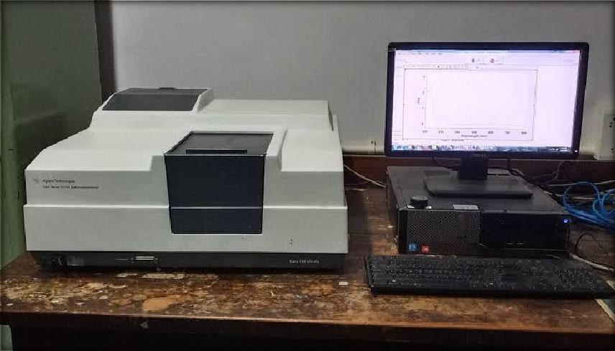
Fig no 5: UV spectrophotometer.

Twenty tablets of metformin hydrochloride were weighed and then powdered using

mortar and pestle. A quantity of the powder equivalent to 0.1 g of metformin hydrochloride was made into solution by adding distilled water, the resulting solution was then diluted with distilled water and the absorbance of the resulting solution was measured using UV- visible spectrophotometer at a wavelength 233 nm. then calculated using calibration curve.

DISSOLUTION
medium phosphate buffer 6.8 PH at temperature 37c by using apparatus type II with speed & time 100rpm &45 min withdraw a suitable volume of the medium & filter, dilute suitably with a water & measure the absorbance of the resulting solution at the maximum at about 233nm.
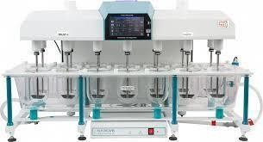
Fig no 6: Dissolution apparatus.

Several dissolution apparatuses exist. In United State pharmacopeia (USP) General Chapter Dissolution, there are four dissolution apparatuses standardized and specified.
They are
  - USP Dissolution Apparatus 1 – Basket (37 °C ± 0.5 °C )
  - USP Dissolution Apparatus 2 – Paddle (37 °C ± 0.5 °C)
  - USP Dissolution Apparatus 3 – Reciprocating Cylinder (37 °C ± 0.5 °C)
  - USP Dissolution Apparatus 4 – Flow-Through Cell (37 °C ± 0.5 °C)
  - USP Dissolution Apparatus 5 - Reciprocating Disk (37 °C ± 0.5 °C
The main objective of developing and evaluating an IVIVC is to establish the dissolution

test as a surrogate for human studies, as stated by the Food & drug Administration (FDA). Analytical data from drug dissolution testing are sufficient in many cases to establish safety and efficacy of a drug product without in vivio tests, following minor formulation and manufacturing changes (Qureshi and Shabnam, 2001). Thus, the dissolution testing which is conducted in dissolution apparatus must be able to provide accurate and reproducible results.

CHAPTER 5
RESULTANDDISCUSSION

RESULT NAD DISCUSSION
- Uniformity of Weight
Table No 3: Uniformity of Weight.

Sr. No | Brand A |  | Brand B |  | Brand C |  | Brand D
Sr. No | Wt (mg) | % Wt Variation | Wt (mg) | % Wt variation | Wt (mg) | % Wt Variation | Wt (mg) | % Wt variation
1) | 530 | 2.51 | 530 | 4.6 | 580 | -1.61 | 550 | 0.54
2) | 510 | -1.35 | 510 | 0.71 | 590 | 0.084 | 560 | 2.37
3) | 520 | 0.58 | 510 | 0.71 | 590 | 0.084 | 530 | -3.10
4) | 500 | -3.2 | 510 | 0.71 | 600 | 1.78 | 550 | 0.54
5) | 520 | 0.58 | 500 | -1.26 | 610 | 3.4 | 560 | 2.37
6) | 520 | 0.58 | 500 | -1.26 | 590 | 0.084 | 550 | 0.54
7) | 520 | 0.58 | 510 | 0.71 | 600 | 1.78 | 540 | -1.27
8) | 530 | 2.51 | 510 | 0.71 | 590 | 0.084 | 540 | -1.27
9) | 520 | 0.58 | 520 | 2.68 | 600 | 1.78 | 550 | 0.54
10) | 510 | -1.35 | 510 | 0.71 | 600 | 1.78 | 560 | 2.37
11) | 510 | -1.35 | 500 | -1.26 | 570 | -3.30 | 530 | -3.10
12) | 520 | 0.58 | 500 | -1.26 | 560 | -5 | 540 | -1.27
13) | 520 | 0.58 | 490 | -3.2 | 570 | -3.30 | 550 | 0.54
14) | 510 | -1.35 | 500 | -1.26 | 590 | 0.084 | 550 | 0.54
15) | 520 | 0.58 | 500 | -1.26 | 600 | 1.78 | 550 | 0.54
16) | 510 | -1.35 | 510 | 0.71 | 580 | -1.61 | 550 | 0.54
17) | 510 | -1.35 | 510 | 0.71 | 580 | -1.61 | 530 | -3.10
18) | 520 | 0.58 | 500 | -1.26 | 570 | -3.30 | 540 | -1.27
19) | 520 | 0.58 | 500 | -1.26 | 580 | -1.61 | 560 | 2.37
20) | 520 | 0.58 | 500 | -1.26 | 590 | 0.084 | 550 | 0.54

- Friability Test
Table no 4: Friability tests.

Tablet Name | Walaphage | Okamet | Glycomet | Glyciphage
Initial Wt (g) | 10.52 | 10.330 | 12.40 | 10.980
Final Wt (g) | 10.50 | 10.310 | 11.80 | 10.940
0% Friability | 0.19% | 0.19% | 4% | 0.36%

- Hardness Test

Table no 5: Hardness test.

Brand A | Brand B | Brand C | Brand D
8.99 kg F | 7.80 kg F | 9.87 kg F | 9.54 kg F

- Assay on UV Spectrometer
Table No 6: Assay of UV Spectrometer.

Name of tablet | Absorbance (nm)
Standard | 3.055
Walaphage | 3.037
Okamet | 3.040
Glycomet | 3.040
Glyciphage | 3.054

DISSOLUTION
Table no 7: Dissolution of all Brands.
60
50
40
30
20
10
0
0
10
Time ( min )
20 30 40
50

Time(min) | Walaphage | Okamet | Glycomet | Glyciphage
5 min | 1.603 | 1.620 | 0.771 | 2.799
15 min | 2.902 | 2.869 | 1.724 | 1.569
30min | 2.809 | 2.902 | 2.663 | 2.023
45 min | 2.783 | 2.819 | 2.749 | 2.384

Graph No 1: Walaphage Calibration Curve.
CDR (%)

- Walaphage
Table no 8: Reading of Walaphage.

Time (Min) | CDR (%)
0 | 0
5 | 18.06
15 | 49.51
30 | 80.96
45 | 95.26
- Okamet

Table no 9: Readings of Okamet.
7
0
60
50
40
30
20
10
0
10
20
Time
30
40
50

Time (min) | CDR (%)
0 | 0
5 | 19.49
15 | 20.92
30 | 33.78
45 | 48.08

Graph No 2: Okamet calibration Curve.
CDR (%)

- Glycomet
7
0
6
0
5
0
4
0
0
10
20
Time
30
40
50
CDR (%)

Graph No 3: Calibration Curve of Glycomet.

Table no 10: Reading of Glycomet.

Time (min) | CDR (%)
0 | 0
5 | 16.63
15 | 19.49
30 | 26.64
45 | 29.35
- Glyciphage

Graph No 4: Calibration Curve of Glyciphage.
70
60
50
40
30
20
10
0
0
10
20
30
40
50
Time (min)
CDR (%)

Table no 11: Reading of Glyciphage.

Time (min) | CDR(%)
0 | 0
5 | 16.63
15 | 22.35
30 | 33.78
45 | 65.24

CHAPTER 6

SUMMERY AND DISCUSSION

SUMMERY AND DISCUSSION
Metformin hydrochloride is a widely prescribed oral anti-diabetic drug. Several brands of Metformin tablets are available in the market leading to a confusion of their quality and prices. The objective of the present study is to make a comparative evaluation of five different brands of Metformin hydrochloride which are commercially available in Libyan market. They were subjected to number of quality control tests in order to assess their biopharmaceutical equivalence. The branded products of Metformin tablets evaluated for various physiochemical properties. The size of tablets was in the range of (11.15 to 15 mm) with all five brands. There is no significant difference between the batches of the brands. The uniformity of weight for the five brands of Metformin hydrochloride tablet gave values that compiled with USP specification and deviated less than 5 % from the mean value. The result of tablet friability test showed that all the brands tested had impressive friability values ranging 0.028% to 0.98% w/w According to USP. no batch should have a friability value greater than 1% w/w. Using hardness tester, the strength of the tablets was tested. Hardness of the tablets was in the range between 21.86 kg/cm to
1.09 kg/cm with all five brands. The observed disintegration times for all the brands of Metformin hydrochloride investigated was less than 30 min. The fastest disintegration

tablets were of Dialon brand was 5,35 min, while the slowest one was Metformin STADA brand was 13.12 min. The various brands could have employed different disintegrates to improve the penetration of aqueous liquids as shown in Table 2. The result obtained from the assessment of the percentage drug content of five brands of Metformin hydrochloride tablets showed within the monograph specification 90 % to 110% of stated amount of Metformin hydrochloride. Dissolution of drug from oral solid dosage forms is an important aspect for drug bioavailability. The in-vitro drug release characteristics of the developed marketed tablets were studied. The dissolution of all five brand tablets indicated more than 70 % of the drug is released within 45 min, which complies with the USP specification.

CHAPTER 7
CONCLUSION

CONCLUSION
  - Four brands of Metformin Hydrochloride 500mg tablets namely walaphage, Glycomet, Okamet & Glyciphage, have been subjected to analysis according to monograph.
  - These results are based on the laboratory analysis
  - Results of this proves that Walaphage, Glycomet, Okamet & Glyciphage sold in pharmacies of India contain the declared amount of active ingredients, fulfil the criteria of weight uniformity, Active ingredient, dissolution rate, hardness, Assay on UV spectrophotometer & friability.
  - All four Brand products could be said to be equivalent to each other as per standards.
  - From all above analysis Okamet Metformin Hydrochloride 500mg is found to be superior as compared to Walaphage, Glycomet & Glyciphage.

CHAPTER 8

REFERENCE

- International Diabetes Federation, clinical Guideline Task Force. Glucose control: Oral therapy, Global Guidelines for Type 2 Diabetes Brusseles, 2005; 35-8.
- Giovanna C, Francesca M, Marzia C, Naima Z, Poala M. Development and evaluation of an in vitro method for prediction of human drug absorption II demonstration of the method suitability. European. 2006; 27: 354-362.
- Werner E, Bell J. The preparation of methylguanidine, and of ββ-dimethylguanidine by the interaction of dicyanodiamide, and methylammonium and dimethylammonium chlorides respectively. J Chem Soc, Transactions, 1921; 121: 1790–5.
- Bailey CJ, Day C. Metformin: its botanical background. Practical Diabetes

International, 2004; 21(3): 115–7.
- Alan D. The use of Medicines in the United States. IMS Institute for Healthcare Informatics (April 2011). 28.
- Adegbolagun OA, Ololade OA, Osamah SE. Comparative evaluation of biopharmaceutical and chemical equivalence of some commercially evaluable brands of ciprofloxacin hydrochloride tablets. Tropical journal of pharmaceutical research, 2007; 6: 737-745.
- Awofisayo OS, Oladoja AA, Nse E, Imo EU. Comparative Assessment of the quality control measurements of multisource ofloxacin tablets marketed in Nigeria. Dissolution Technologies, 2010; 6: 20-25.
- Esiomone CO, Okoye FBC, Onah BU, Nworu CS, Omeje EO. In-vitro bioequivalence study of nine brands of artesunate tablets marketed in Nigeria. J.Vector Borne Dis, 2008; 45: 60-65.
- Pamula RB, Surender G, Reddy KVS, Ujwala P, Jyosthna G, Kumar RM. Comparative in vitro evaluation of commercial metformin HCL tablets. JITPS, 2010; 1: 152-157.
- Chow SJ. Pharmaceutical Validation and process controls in drug development. J Drug development, 1997; 31: 1195-1201.
- Jantratid E, Janssen N, Reppas C, Dressman J. B. Dissolution media simulating conditions in the proximal human gastrointestinal tract: an update. Pharm. Res., 2008; 25: 1663–1676.
- Osadebe PO, Akabogu A. Assessment of qualitycontrol parameters and interchangeability of multisourced metformin hydrochloride tablets marketed in Nigeria. Boll. Chim. Farm., 2004; 143: 170–173.
- Moore JW, Flanner HH. Mathematical comparison of dissolution profiles. Pharm Technol., 1996; 20: 64-74.
- Voegele, D. Drug release in vitro: An aid in clinical trials? Met. Find. Exp. Clin. Pharmacol, 1992; 21: 55–62.
- Akinleye MO, Adelaja IA, Odulaja JO. Comparative Evaluation of Physicochemical Properties of Some Commercially Available Brands of Metformin Hcl Tablets in Lagos, Nigeria. Journal of Applied Pharmaceutical Science, 2012; 2: 41-44.
- Pamula RB, Surender G, Reddy KV, Ujwala P, Gangishetti J, Kumar RM. Comparative in vitro evaluation of commercial metformin hydrochloride tablets. JITPS, 2010; 2: 152–157.

- Polli JE, Rekhi S, Augsburger LL, Shah VP. Methods to compare dissolution profiles and a rationale for wide dissolution specifications for metoprolol tatrtarate tablets. J. Pharm. Sci., 1997; 86: 690-700.
- Balan G, Timmins P, Greene DS, Marathe PH. In vitro-in vivo correlation (IVIVC) models for metformin after administration of modified-release (MR) oral dosage forms to healthy human volunteers. J.Pharm. Sci., 2001; 90: 1176-1185.
- Imad H, Ahmed BJ. Pharmaceutical Evaluation of Metformin HCl Products Available in the Jordanian Market. Jordan Journal of Pharmaceutical Sciences, 2010; 2: 1-7.
- Arcot RC, Chan J, Choong T, Teeba M, Selvadurai M, Sokkalingam A. In-vitro studies and evaluation of Metformin marketed tablets-Malaysia. Journal of Applied Pharmaceutical Science, 2011; 1: 214-217.
- Martindale: The Complete Drug Reference, 33rd ed.; Sweetman, S.C., Ed.; Pharmaceutical Press: London, (2002).

FUTURE SCOPE OF RESEARCH
The present study on the phytochemical screening and nutritional assessment of Zingiber officinale provides foundational information; however, several areas remain open for further investigation. Future research can focus on the quantitative estimation of major phytochemicals such as gingerols, shogaols, flavonoids, and phenolic compounds using advanced analytical techniques like HPLC and GC–MS. This would allow precise determination of bioactive compounds responsible for specific therapeutic effects.
Further studies may evaluate the antioxidant, antimicrobial, anti-inflammatory, antidiabetic, and anticancer activities of ginger extracts through in vitro and in vivo experiments. Investigating the bioavailability, metabolism, and toxicity profile of active constituents is essential to ensure safety and efficacy for long-term use. Clinical trials could be conducted to validate traditional claims and to establish recommended dosage levels.
Research can also explore the impact of geographical location, cultivation practices, harvesting time, and processing methods on the phytochemical and nutritional composition of Zingiber officinale. Additionally, the development of value-added products, such as nutraceuticals, functional foods, herbal formulations, and natural preservatives, presents significant industrial potential.
Future studies may also focus on standardization and quality control protocols for ginger-based products to ensure consistency and effectiveness. Overall, extensive multidisciplinary research will help unlock the full medicinal and nutritional potential of Zingiber officinale and support its broader application in food, pharmaceutical, and healthcare sectors.
Comparative studies on fresh, dried, and processed ginger to evaluate changes in phytochemical and nutritional profiles.
Exploration of nano-formulations and encapsulation techniques to improve the stability, bioavailability, and controlled release of ginger bioactives.
Investigation of the synergistic effects of Zingiber officinale when combined with other medicinal plants or dietary components.
Study of ginger’s role in gut health and microbiome modulation due to its bioactive compounds and dietary fiber content.
Evaluation of ginger extracts as natural food preservatives and flavoring agents with antimicrobial and antioxidant properties.
Research on sustainable cultivation practices to enhance yield and phytochemical content while reducing environmental impact.
Genetic and molecular studies to identify varieties or cultivars with higher medicinal and nutritional value.
Assessment of the potential use of ginger by-products and waste in cosmetics, animal feed, and agricultural applications.
Development of standard dosage forms such as capsules, tablets, teas, and functional beverages.
Long-term epidemiological studies to understand the health benefits of regular ginger consumption in different populations.

CHAPTER 9

REFERENCES

REFERENCES
1. Osabor, V. N., Bassey, F. I., & Umoh, U. U. (2015). Phytochemical Screening and Quantitative Evaluation of Nutritional Values of Zingiber officinale (Ginger). Chemical Science International Journal, 8(4), 1–6. DOI:10.9734/ACSJ/2015/16915 — Phytochemical and proximate nutritional analysis of ginger rhizome.
2. Yasodai, R., Kavimani, M., & Prabhu, K. (2020). Phytochemical analysis and quantitative nutritional evaluation of Zingiber officinale Roscoe (Ginger). International Journal of Research in Pharmacy and Science, 11(2), 2090–2094 — Reports bioactive compounds and minerals in ginger extracts.
3. Ibeabuchi, C. G., Oyeike, E. N., Akaninwor, J. O., & Patrick-Iwuanyanwu, K. C. (2024). Qualitative and Quantitative Phytochemical Screening and Antioxidant Capacity of Zingiber officinale, Ocimum gratissimum and their Mixture. Journal of Public Health and Toxicological Research — Discusses phytochemicals and antioxidant activity.
4. (2020). Phytochemical constituents and nutrient evaluation of Zingiber officinale. Tikrit Journal of Pure Science — Provides quantitative phytochemical and nutrient data including mineral and vitamin contents.
5. Amba, U. et al. (2017). Phytochemical Screening and Effect of Temperature on Proximate Analysis and Mineral Composition of Zingiber officinale Rosc. Biotechnology Journal International, 18(3) — Studies phytochemicals and proximate composition under varying conditions.
6. Phytochemical screening and evaluation of the antioxidant and antibacterial potential of Zingiber officinale extracts. South African Journal of Botany, 142 — Reports mineral profiles and bioactive compounds in ginger extracts.
7. Food Value of Two Varieties of Ginger (Zingiber officinale) Commonly Consumed in Nigeria. Journal of Food Composition and Analysis — Nutritional and phytochemical comparisons of ginger varieties.
8. Phytochemical screening, GC-MS and antidiabetic properties of ginger (Zingiber officinale) extract in alloxan-induced diabetic rats. Journal of Pharmacognosy and Phytochemistry, 11(5) — Includes GC-MS profiling of bioactives.
9. Zamir, I., Hussain, S., Javed, M., & Munawar, K. S. (2020). Phytochemical Composition of Ginger, its Nutritional and Pharmacological Importance. Lahore Garrison University Journal of Life Sciences — Overview of nutritional components and health benefits.
10. Ali, B. H., Blunden, G., Tanira, M. O., & Nemmar, A. (2008).
Some phytochemical, pharmacological and toxicological properties of ginger
(Zingiber officinale Roscoe): A review of recent research.
Food and Chemical Toxicology, 46(2), 409–420.
11. Shukla, Y., & Singh, M. (2007).
Cancer preventive properties of ginger: A brief review.
Food and Chemical Toxicology, 45(5), 683–690.
12. Ghasemzadeh, A., Jaafar, H. Z. E., & Rahmat, A. (2010).
Antioxidant activities, total phenolics and flavonoids content in two varieties of Malaysia young ginger (Zingiber officinale Roscoe).
Molecules, 15, 4324–4333.
13. Park, M., Bae, J., & Lee, D. S. (2008).
Antibacterial activity of [10]-gingerol and [12]-gingerol isolated from ginger rhizome against periodontal bacteria.
Phytotherapy Research, 22(11), 1446–1449.
14. AOAC (2019).
Official Methods of Analysis of AOAC International.
Association of Official Analytical Chemists, Washington, DC.
(Reference for proximate and nutritional analysis methods.)
15. Harborne, J. B. (1998).
Phytochemical Methods: A Guide to Modern Techniques of Plant Analysis.
Springer, London.
(Standard reference for phytochemical screening procedures.)
16. Sofowora, A. (2008).
Medicinal Plants and Traditional Medicine in Africa.
Spectrum Books Ltd., Ibadan.
(Common reference for qualitative phytochemical tests.)
17. Trease, G. E., & Evans, W. C. (2009).
Pharmacognosy (16th ed.).
Elsevier, London.
(Standard textbook reference for medicinal plant studies.
18. WHO (2007).
Evaluation of certain food additives and contaminants.
World Health Organization Press, Geneva.
(Useful for safety and dietary relevance.)
19. FAO/WHO (2011).
Guide to food safety and nutritional evaluation of plant products.
Food and Agriculture Organization of the United Nations.

